Chapter 1: What Is the Stock Market?
Imagine your favourite coffee brand, say, Tata Coffee, wants to open 500 new outlets across India. That kind of expansion needs money, to buy land, build stores, hire staff, and market the brand.
Instead of borrowing a huge amount from banks, the company can raise money by offering ownership stakes, called shares, to people like you and me.
When you buy a share, you’re not just investing your money, you’re becoming a co-owner of that company.
If the business does well, earns profits, and grows in value, your share becomes more valuable too. You might even receive a dividend, which is a part of the company’s profits distributed to shareholders.
That’s the essence of the stock market, a large, organized marketplace where companies raise funds and investors participate in their success.

Where All Listed Companies Live
Every company whose shares are available for the public to buy and sell is called a listed company.
To get listed, a company must go through a strict approval process with SEBI (Securities and Exchange Board of India) and the stock exchanges — mainly NSE (National Stock Exchange) and BSE (Bombay Stock Exchange).
When a company is “listed,” it means:
- Its shares are available to be traded publicly on the exchange.
- It must follow transparency and disclosure rules — sharing financial results, management updates, and business plans regularly.
- It becomes accountable to its shareholders — you, me, and millions of other investors.
Being listed is a badge of trust and credibility.
It signals that a company is willing to open its books to public scrutiny and share its journey with investors.
Today, thousands of companies, from household names like Reliance, Infosys, and HDFC Bank to emerging startups like Nykaa and Zomato, are listed on India’s stock exchanges.

A Marketplace Built on Belief
Unlike a regular marketplace where you buy goods, in the stock market, you’re buying potential, the future of businesses you believe in.
You don’t walk away with a product; you walk away with ownership.
And because these shares are traded daily, their prices move constantly, driven by demand, supply, company performance, global events, and even investor sentiment.
The stock market, in that sense, is a living, breathing reflection of the economy.
When companies thrive, jobs grow, innovation flourishes, the investors prosper.
When they struggle, the ripple is felt across the market.
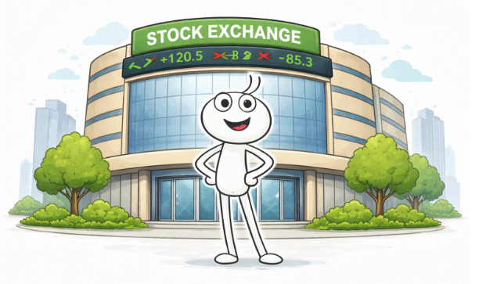
Chapter 2: Why Does the Stock Market Exist?
The stock market exists because ambition always needs fuel and that fuel is capital.
Before stock markets, only kings, banks, or wealthy merchants could fund businesses.
When the Dutch East India Company issued the first shares in the 1600s, it changed everything. Suddenly, ordinary citizens could invest in global trade. That simple innovation gave rise to the global economy we know today.
In India, companies like Infosys, TCS, and Reliance have used the market to raise funds and expand, creating jobs, innovation, and wealth in the process.
So, every trade isn’t just a number on a screen, it’s investment that drives growth across the country.

Chapter 3: The Key Players — Who Makes It All Work
When you tap ‘Buy’ on your trading app, it may look like magic but behind that instant click lies an intricate web of institutions, technology, and trust.
Each player in this system has a unique role, and together, they make sure that every trade, no matter how small, is executed safely, accurately, and fairly.
Let’s walk through the process and the people behind it

1. Investors — The Heartbeat of the Market
Investors are the life force of the stock market.
They can be:
- Retail Investors: Everyday people investing through apps like Zerodha or Groww.
- Institutional Investors: Big entities like mutual funds, insurance companies, or pension funds.
- Foreign Institutional Investors (FIIs): Global funds investing in Indian markets, often influencing trends and liquidity.
Every rupee invested fuels the market, and collectively, investors decide which businesses is valuable and which is not.

2. Brokers — The Bridge Between You and the Market
You can’t directly trade on the stock exchange, you need a registered broker to place your order.
Platforms like Zerodha, Upstox, Angel One, Groww, and ICICI Direct act as intermediaries.
When you click ‘Buy’, your order is routed to your broker’s system → sent to the exchange in real time → matched with a seller’s order.
Brokers also:
- Maintain your trading account (for buying/selling activity).
- Provide analytics, charts, and reports.
- Ensure KYC and regulatory compliance under SEBI guidelines.
In short, your broker is the access point to the market’s entire ecosystem.

3. Stock Exchanges — The Marketplace
The National Stock Exchange (NSE) and Bombay Stock Exchange (BSE) are where trades actually happen.
They don’t own the companies, they simply provide a platform for buying and selling shares securely and transparently.
Here’s what happens on the exchange:
- Your buy order is matched with someone’s sell order (based on price and time priority).
- Once matched, a trade confirmation is generated instantly.
Think of it as the market’s matchmaker, connecting buyers and sellers across India in milliseconds.

4. Clearing Corporations — The Market’s Guarantee
Once a trade is matched, it moves to the clearing stage, handled by clearing corporations like NCL (NSE Clearing Ltd.) or Indian Clearing Corporation Ltd. (ICCL).
Their role is to:
- Verify both parties, the buyer has enough money and the seller actually owns the shares.
- Temporarily “lock” the shares and funds until the trade is settled.
- Guarantee completion, even if one party defaults.
This ensures that no one loses money due to counterparty risk. It’s the invisible insurance system that makes investors trust the market.

5. Depositories — The Digital Vaults
Gone are the days of paper share certificates.
Today, all your holdings are stored digitally with NSDL (National Securities Depository Ltd.) or CDSL (Central Depository Services Ltd.).
Here’s how it works:
- When you buy shares, they’re credited to your Demat account (like a digital locker).
- When you sell, they’re debited automatically.
- Your broker is linked to one of these depositories through a Depository Participant (DP), typically the same app you trade on.
Your Demat account proves your ownership, it’s as important as your bank account in the world of investing.

6. SEBI — The Watchdog of the Market
The Securities and Exchange Board of India (SEBI) is the regulator that ensures markets run with fairness, transparency, and accountability.
It:
- Sets the rules for brokers, companies, and investors.
- Monitors insider trading and fraud.
- Approves IPOs and corporate actions.
- Ensures timely disclosure of financial results by listed companies.
SEBI’s presence gives confidence to investors that the market operates on equal footing for everyone, from a college student investing ₹500 to a global fund moving crores.

Putting It All Together — The Journey of a Trade
Let’s say you decide to buy 10 shares of Infosys at ₹1,500 each.
Here’s what happens, step by step:
- You (the investor) place the order through Groww (your broker).
- Groww forwards your order to the NSE (the exchange).
- The NSE’s system finds a seller offering 10 shares at ₹1,500 — a match!
- The trade is confirmed instantly and sent to the clearing corporation (NCL).
- NCL checks:
  - You have ₹15,000 in your trading account.
  - The seller has 10 Infosys shares in their Demat account.
- Once verified, the clearing corporation transfers:
  - ₹15,000 to the seller’s broker account.
  - 10 shares from the seller’s Demat to your Demat account (held with CDSL/NSDL).
- Within one business day (T+1), the shares appear in your holdings.
Throughout this, SEBI oversees the process, ensuring no foul play, delays, or manipulation.
In less than a second, your order travelled through half a dozen institutions, seamlessly, securely, and silently.
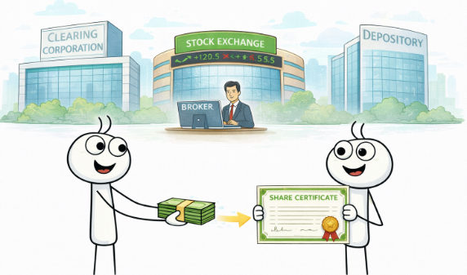

Chapter 4: IPOs & FPOs — How Companies Raise Money
An IPO (Initial Public Offering) is when a private company becomes public, inviting people to invest for the first time.
Think of companies like Zomato, Nykaa, and LIC, their IPOs created buzz across India.
For investors, it’s a chance to be part of a company’s growth story early on.
For the company, it’s access to funds to expand operations, repay debt, or innovate.
An FPO (Follow-on Public Offering) happens when a listed company issues more shares, like a “second round” of funding.
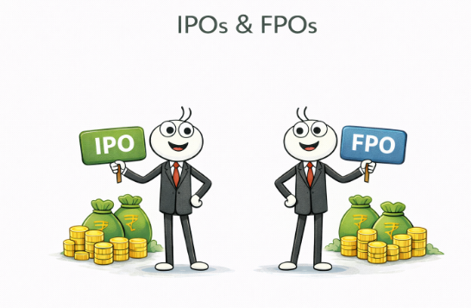
Chapter 5: Indices — The Market’s Pulse
The heartbeat that tells you how healthy the market really is.
If the stock market were a cricket match, indices would be the scoreboard.
They don’t tell you everything that’s happening in every over but they give you a quick sense of which way the game is going.
In the same way, a stock market index measures how a specific group of companies is performing, helping investors understand the overall mood, trend, and direction of the market.

Understanding What an Index Really Is
An index is simply a basket of selected companies that represent the broader market or a particular sector.
When you hear that the Sensex or Nifty 50 has moved up or down, it means the prices of the companies in that basket have, on average, risen or fallen.
Each index is built to represent a specific slice of the economy:
- Nifty 50: 50 of the largest and most liquid companies listed on the NSE.
- Sensex: 30 leading companies listed on the BSE.
Together, these two are like the twin thermometers of India’s financial climate.

A Closer Look at the Big Two
Sensex (Sensitive Index)
- Launched in 1986 by the Bombay Stock Exchange.
- Tracks 30 of the biggest and most established companies in India.
- Includes firms like Reliance Industries, HDFC Bank, Infosys, TCS, and ICICI Bank.
Because these companies come from different sectors — IT, banking, energy, manufacturing, FMCG, the Sensex acts as a mini snapshot of India’s corporate health.
Nifty 50 (National Fifty)
- Introduced by the National Stock Exchange in 1996.
- Includes 50 large-cap companies across 13 sectors of the economy.
- Represents over 60% of the total market capitalization of all NSE-listed companies.
When people say, “The market is up today,” they’re usually referring to the Nifty, it’s the most followed barometer of Indian investor sentiment.

How Indices Reflect the Economy
Each sector plays its own role in the index, IT reflects global demand for technology, banks represent credit and growth, and consumer companies mirror spending power.
When the Nifty or Sensex rises, it signals optimism, companies are performing well, profits are growing, and investors are confident.
When they fall, it suggests caution, maybe due to global slowdowns, inflation, policy changes, or reduced spending.
In that sense, indices are economic mood boards, capturing everything from government policy and global oil prices to consumer demand and foreign investment.

Sectoral and Thematic Indices
Beyond the Nifty and Sensex, there are many sectoral indices that track specific industries:
- Nifty Bank – Leading banking and financial companies.
- Nifty IT – Tech giants like Infosys, TCS, and Wipro.
- Nifty FMCG – Everyday brands like HUL, Nestlé, and Dabur.
- Nifty Pharma, Nifty Auto, Nifty Energy, and more.
These help investors focus on particular sectors they understand or believe in.
For example, someone optimistic about India’s digital growth might invest in the Nifty IT index, while a long-term believer in consumption might prefer Nifty FMCG.

How Indices Are Calculated
Each company in an index doesn’t carry equal weight.
The impact of a company’s price change on the index depends on its market capitalization, the total value of all its shares.
So, a 1% move in Reliance (a large-cap stock) can affect the index much more than a 1% move in a smaller company.
In short:
Big companies move the index more, small ones just follow along.

Why Indices Matter to You
Indices are not just indicators, they’re also benchmarks and tools:
- Benchmarking Performance: Mutual funds and portfolio managers compare their returns against indices like Nifty 50 to judge performance.
- Index Funds & ETFs: These allow you to invest directly in the index itself, owning a slice of all 50 or 30 companies.
- Market Sentiment: The direction of the index helps everyday investors decide whether to be cautious, neutral, or optimistic.
That’s why every news anchor, trader, and long-term investor watches indices like a doctor checks a patient’s pulse, regularly, carefully, and with context.
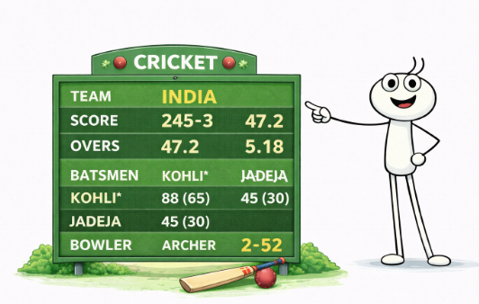
Chapter 6: Understanding the Basics — Key Jargon Simplified
When you first step into the world of investing, the jargon can feel overwhelming, like a new language everyone else already speaks.
But once you get familiar with a few key terms, the market starts to make a lot more sense.

The Everyday Terms You’ll Hear
Stock / Share:
A share represents a single unit of ownership in a company. If a company has issued 1 crore shares and you own 1,000 of them, you literally own 0.001% of that company.
Equity:
Another word for ownership, it means you’re not lending money to a company (like a bondholder), you actually own part of it.
Market Capitalization (Market Cap):
The total market value of a company.
Market Cap=Share Price × Total Shares Outstanding
Example: If Reliance’s share price is ₹3,000 and it has 675 crore shares, its market cap is around ₹20 lakh crore, making it one of India’s largest companies.
Bull Market:
When optimism runs high and prices keep climbing. Investors expect growth, companies perform well, and markets move up, like a bull charging ahead.
Bear Market:
When fear or pessimism dominates and stock prices fall for an extended period, like a bear swiping its paws downward.
Portfolio:
Your personal collection of investments, stocks, mutual funds, bonds, real estate, even gold. A well-diversified portfolio spreads risk across assets.
Dividend:
A company’s way of sharing profits with shareholders.
Example: Infosys often rewards its investors with dividends, a thank-you for believing in the company.

Chapter 7: Let’s Talk About Corporate Actions
Owning a share doesn’t just mean watching prices go up and down, companies often take actions that directly impact your holdings.
These are called corporate actions, and they can change the number of shares you own, their value, or your income.
Here are the most common ones
1. Bonus Issue:
Free shares issued to existing shareholders, often in a fixed ratio.
Example: If a company announces a 1:1 bonus, you get one additional share for every share you already own.
It’s like getting an extra slice of cake without paying more, your total holding increases, but the overall value stays the same.
2. Stock Split:
When a company divides its existing shares into smaller units to make them more affordable and increase liquidity.
Example: A 1:5 split means each ₹100 share becomes 5 shares of ₹20 each. The total value doesn’t change, but smaller investors can now buy in more easily.
3. Dividend Payouts:
Companies distribute a portion of their profits to shareholders.
Example: If TCS announces a ₹24 dividend per share, and you own 100 shares, you’ll receive ₹2,400 directly in your bank account.
4. Rights Issue:
A company offers existing shareholders the chance to buy more shares, usually at a discount, to raise additional funds.
Example: A 1:4 rights issue means you can buy one extra share for every four you already own, often at a lower price.
5. Buyback:
When a company repurchases its own shares from the market.
This reduces the number of shares in circulation, often boosting earnings per share (EPS) and, in turn, the stock price.
Example: Infosys and Wipro frequently announce buybacks as a way to reward investors.
6. Merger or Demerger:
- Merger: Two companies combine to form a new entity (like HDFC and HDFC Bank merging).
- Demerger: A company splits a business unit into a separate entity (like Reliance spinning off Jio Financial).
These actions can reshape your portfolio, as you may receive new shares in the merged or separated company.

Chapter 8: Wrapping Up — You Now Speak the Market’s Language
You’ve come a long way.
From understanding what the stock market really is to learning how trades happen, who makes them work, and what those confusing terms mean, you’ve built the foundation every investor needs.
The jargon that once felt like noise now makes sense.
You know what it means when someone says, “Nifty’s up, Reliance announced a buyback, and SEBI’s tightening regulations.”
That’s real progress and it’s the kind of knowledge that gives you confidence to participate, not just observe.
You now understand that the market isn’t some abstract casino, it’s a living ecosystem of businesses, investors, and systems working together.
And when you invest, you’re putting your money behind ideas, people, and companies shaping the economy’s future.
As we move forward, things will get a bit more practical.
The next phase is where we start exploring how to read markets, analyze companies, and make smarter investment choices, all with a calm head and a clear goal.
So take a moment to appreciate getting this far.
Most people never look beyond the headlines. You just did.
Let’s move on, the real investing journey begins now.


